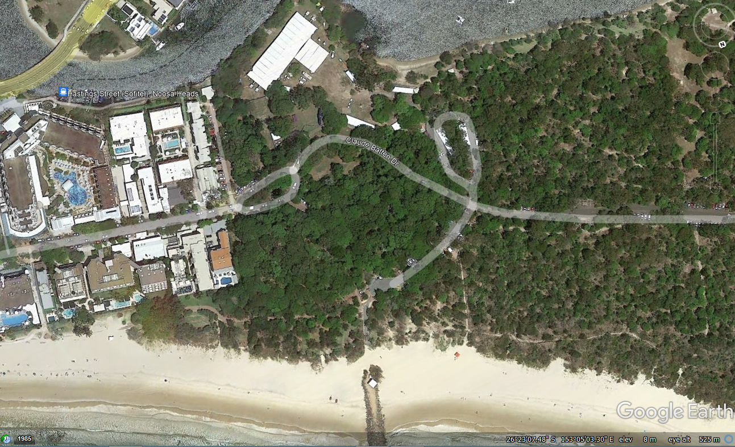
Signs directing
trailers/cars
to parking

Sign 9
Sign 8
Sign 7
Sign 6
Sign109
Sign 4
Sign 5
Sign 3
Sign 2
Sign 1
Sign 1

